**Week 5- Microservices with API gateway hands on**

**Name-Adi Jain**

**Superset ID- 6390400**

**Hands on 1**

Creating Microservices for account and loan.

**Account**

**Code**

**File Name: AccountController.java**

**package** com.cognizant.account.controller;

**import** org.springframework.web.bind.annotation.GetMapping;

**import** org.springframework.web.bind.annotation.PathVariable;

**import** org.springframework.web.bind.annotation.RestController;

**import** java.util.HashMap;

**import** java.util.Map;

@RestController

**public** **class** AccountController {

@GetMapping("/accounts/{number}")

**public** Map<String, Object> getAccountByNumber(@PathVariable String number) {

Map<String, Object> account = **new** HashMap<>();

account.put("number", number);

account.put("type", "savings");

account.put("balance", 234343);

**return** account;

}

}

===========================================================================

**File Name: pom.xml**

<project xmlns="http://maven.apache.org/POM/4.0.0" xmlns:xsi="http://www.w3.org/2001/XMLSchema-instance"

xsi:schemaLocation="http://maven.apache.org/POM/4.0.0 https://maven.apache.org/xsd/maven-4.0.0.xsd">

<modelVersion>4.0.0</modelVersion>

<parent>

<groupId>org.springframework.boot</groupId>

<artifactId>spring-boot-starter-parent</artifactId>

<version>3.5.3</version>

<relativePath/> <!-- lookup parent from repository -->

</parent>

<groupId>com.cognizant</groupId>

<artifactId>account</artifactId>

<version>0.0.1-SNAPSHOT</version>

<name>account</name>

<description>Demo project for Spring Boot</description>

<url/>

<licenses>

<license/>

</licenses>

<developers>

<developer/>

</developers>

<scm>

<connection/>

<developerConnection/>

<tag/>

<url/>

</scm>

<properties>

<java.version>17</java.version>

</properties>

<dependencies>

<dependency>

<groupId>org.springframework.boot</groupId>

<artifactId>spring-boot-starter-web</artifactId>

</dependency>

<dependency>

<groupId>org.springframework.boot</groupId>

<artifactId>spring-boot-devtools</artifactId>

<scope>runtime</scope>

<optional>true</optional>

</dependency>

<dependency>

<groupId>org.springframework.boot</groupId>

<artifactId>spring-boot-starter-test</artifactId>

<scope>test</scope>

</dependency>

</dependencies>

<build>

<plugins>

<plugin>

<groupId>org.springframework.boot</groupId>

<artifactId>spring-boot-maven-plugin</artifactId>

</plugin>

</plugins>

</build>

</project>

**===========================================================================**

**Output- Folder Structure**

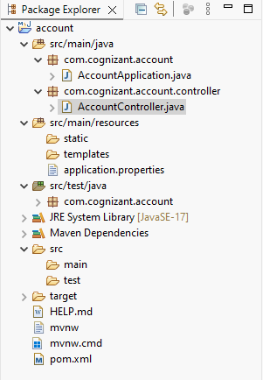

**========================================================**

**Final Output**

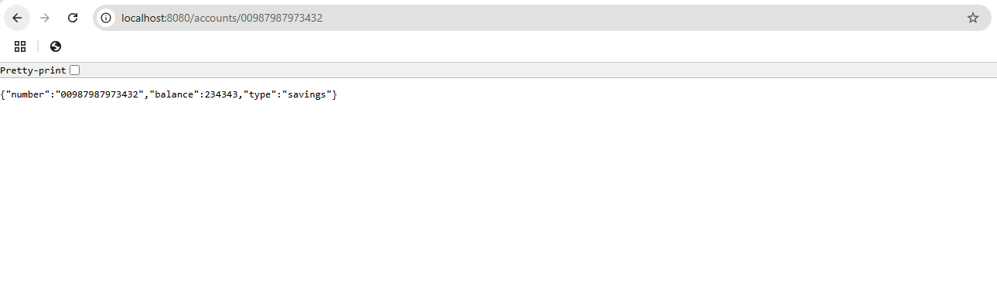

**========================================================**

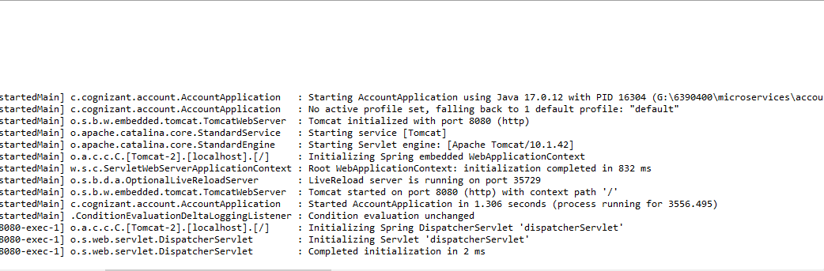

**=======================================================**

**Loan**

**Code**

**File Name: LoanController.java**

**package** com.cognizant.loan.controller;

**import** org.springframework.web.bind.annotation.*;

**import** java.util.Map;

@RestController

@RequestMapping("/loans")

**public** **class** LoanController {

@GetMapping("/{number}")

**public** Map<String, Object> getLoan(@PathVariable String number) {

**return** Map.*of*(

"number", number,

"type", "car",

"loan", 400000,

"emi", 3258,

"tenure", 18

);

}

}

**========================================================**

**File name: pom.xml**

<project xmlns="http://maven.apache.org/POM/4.0.0" xmlns:xsi="http://www.w3.org/2001/XMLSchema-instance"

xsi:schemaLocation="http://maven.apache.org/POM/4.0.0 https://maven.apache.org/xsd/maven-4.0.0.xsd">

<modelVersion>4.0.0</modelVersion>

<parent>

<groupId>org.springframework.boot</groupId>

<artifactId>spring-boot-starter-parent</artifactId>

<version>3.5.3</version>

<relativePath/> <!-- lookup parent from repository -->

</parent>

<groupId>com.cognizant</groupId>

<artifactId>loan</artifactId>

<version>0.0.1-SNAPSHOT</version>

<name>loan</name>

<description>Demo project for Spring Boot</description>

<url/>

<licenses>

<license/>

</licenses>

<developers>

<developer/>

</developers>

<scm>

<connection/>

<developerConnection/>

<tag/>

<url/>

</scm>

<properties>

<java.version>17</java.version>

</properties>

<dependencies>

<dependency>

<groupId>org.springframework.boot</groupId>

<artifactId>spring-boot-starter-web</artifactId>

</dependency>

<dependency>

<groupId>org.springframework.boot</groupId>

<artifactId>spring-boot-devtools</artifactId>

<scope>runtime</scope>

<optional>true</optional>

</dependency>

<dependency>

<groupId>org.springframework.boot</groupId>

<artifactId>spring-boot-starter-test</artifactId>

<scope>test</scope>

</dependency>

</dependencies>

<build>

<plugins>

<plugin>

<groupId>org.springframework.boot</groupId>

<artifactId>spring-boot-maven-plugin</artifactId>

</plugin>

</plugins>

</build>

</project>

**========================================================**

**Output- Folder Structure**

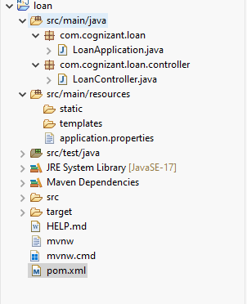

**========================================================**

**Final Output**



